J01. Edward J. Cooke series [1901]

Ph & Pu Edward J. Cooke
F Printed with each photograph occupying the left-hand third of the card and placed within a wavy line frame containing title of view and the words 'Copyright/Edward J. Cooke, Photo.' Many cards are also rubber-stamped 'Regd. 6/11/01 - E.J.C.' or have this same wording printed below the photograph. This relates back to the short-lived practice of demanding formal registration of copyright. Some have the title printed both as above and hand-lettered on the negative so that it appears in white on the photograph. Back is undivided. All cards are H format, but pictures of H format are turned on one edge. Thus, details of format recorded below refer to the picture format only.

Printed in Sepia, ‘Rgtd. 6/11/01 E.J.C.’ generally rubberstamped

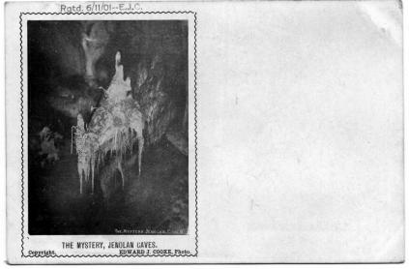 | 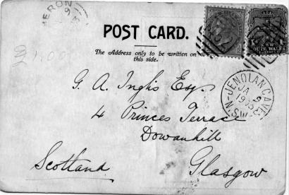

J01A.1 The Mystery, Jenolan Caves V [pm.2 Dec.1901]
J01A.2 Grand & Carlotta Arches, Jenolan Caves V [Jenolan pm.21 Mar 1902]
J01A.3 Cave House, Jenolan Caves V [pm.1906]
J01A.4 The Carlotta Arch V [pm.17 Mar.1905]
J01A.5 The Broken Column, Jenolan Caves V [Jenolan pm.1 Jan.1902]
J01A.6 Show Room, Jenolan Caves V [pm. 1901]
J01A.7 Subterranean River, Jenolan Caves H [pm.2 Dec.1901]
One sender (Jenolan pm. 17 Jan 1903) says 'I am writing from the interior of this cave (700 ft. underground). To reach these caves we had to drive seventy-two miles over the Mountains, and thro' the grandest and most lovely scenery imaginable.'
J01A.8 Crystal Cities, Jenolan Caves H [Jenolan pm.18 Mar.1902] *
Sender reports 'We have been staying at Katoomba, and this morning took the
mail train to Mt. Victoria and from there, a distance of 36 m., we drove in a
coach through lovely scenery. We arrived here at 3.00 p.m. and at once went
into one of the caves. It was perfectly beautiful. We are going into another
tomorrow morning and then drive back to Mt. Victoria.'
J01A.9 Nellie's Grotto, Jenolan Caves H [pm.1903] *
One example [Jenolan pm.9 Jan.1903] is addressed to Glasgow, and sender says, '. . . having a great time here, & am seeing some of the most wonderful caves in the world.'
J01A.10 Coral Grotto, Jenolan Caves H (title on picture reads "Coral Grotto, No.
15")
J01A.1J01A Grand Stalactites, Jenolan Caves H [Jenolan pm.29 Jan.1902]
J01A.1J01B Grand Stalactites, Jenolan Caves H [pm.3 Jun.1904]
This card has title printed in Italic caps., and also 'Registered 6/11/04 E.J.C.' is
printed immediately below title. Message on card says 'This is a poor picture.
The roof of this is about somewhere the same as the roof of our woolshed.'
J01A.12 Interior of Grand Arch, Jenolan Caves H

J01B. Printed in Grey; ‘Registered 6/11/01. E.J.C.’ is printed

J01B.2 Grand and Carlotta Arches, Jenolan Caves V [Jenolan pm. 31 Dec 1903]
J01B.3 Cave House, Jenolan Caves V
J01B.7 Subterranean River, Jenolan Caves H
J01B.9 Nellie's Grotto, Jenolan Caves H
J01B.10 Coral Grotto, Jenolan Caves H (title on picture reads "Coral Grotto, No. 15")
[Jenolan pm. 30 Oct 1903]
J01B.11 Grand Stalactites, Jenolan Caves H *
J01B.12 Interior of Grand Arch, Jenolan Caves H *

Printed in Blue; ‘Registered 6/11/01. E.J.C.’ is printed

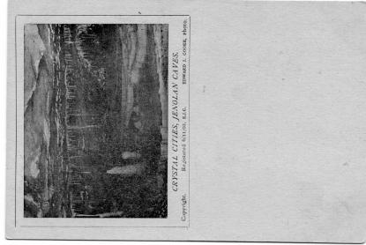 | J01C.8 Crystal Cities, Jenolan Caves H

Cooke also took individual photographs of visitors or groups of visitors (see 2.16)

